**Assignment 9**

**Use sub-query to solve following problems.**

**Note : To solve below queries use “sales” database**

1. Write a query that uses a subquery to obtain all orders for the customer named Cisneros. Assume you do not know his customer number (cnum).

**select * from orders where snum=(select snum from customers where cname='cisneros');**

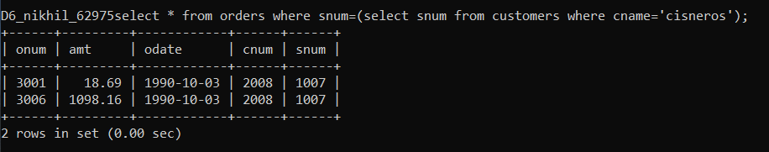

1. Write a query that produces the names and ratings of all customers who have aboveaverage orders.

**select cname,rating from customers where cnum=any(select cnum from orders where amt>(select avg(amt) from orders));**

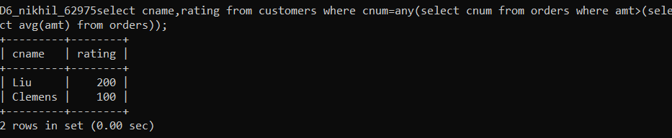

1. Write a query that selects the total amount in orders for each salesperson for whom this total is greater than the amount of the largest order in the table.

**select s.sname,sum(o.amt) from salespeople s inner join orders o on s.snum=o.snum group by s.sname having sum(o.amt)>(select max(amt) from orders);**

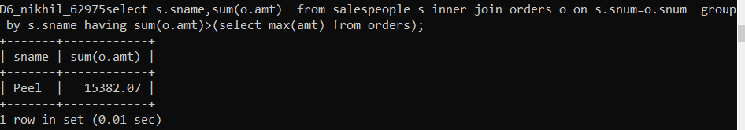

**select snum,sum(amt) from orders group by snum having sum(amt)>(select max(amt) from orders);**

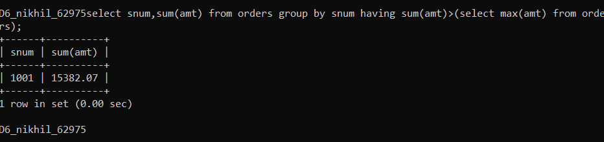

1. Write a query that selects all customers whose ratings are equal to or greater than ANY of Serres’.

**select * from customers where rating>=any(select rating from customers where snum=(select snum from salespeople where sname='serres')) and snum!=1002;**

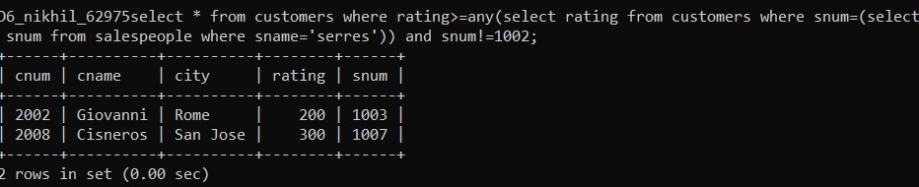

1. Write a query using ANY or ALL that will find all salespeople who have no customers located in their city.

**select * from salespeople where (snum,city)!=all(select snum,city from customers);**

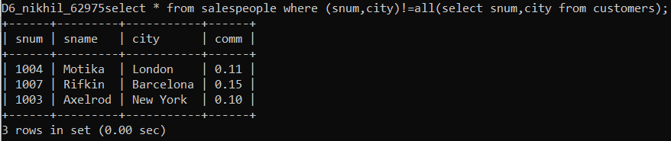

1. Write a query that selects all orders for amounts greater than any for the customers in London.

**select * from orders where amt>any(select amt from orders where cnum=any( select cnum from customers where city='london'));**

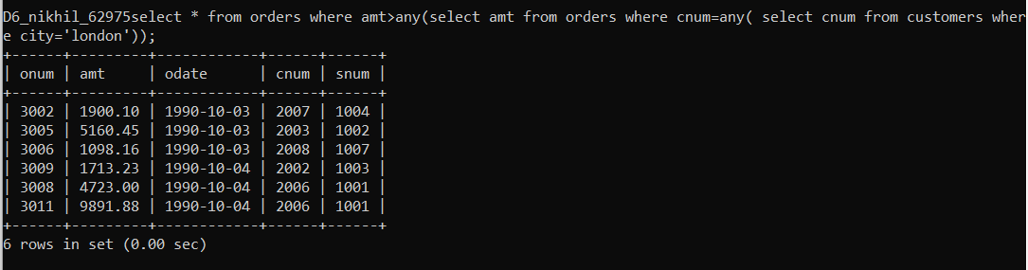

1. Extract all the orders of Motika

**select * from orders where snum=(select snum from salespeople where sname='motika');**

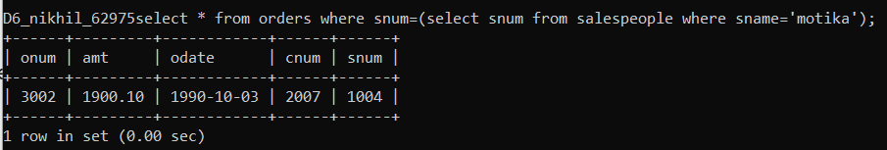

1. Find all the order attribute to salespeople servicing customers in London.

**select * from orders where snum=any(select snum from salespeople where snum=any(select snum from customers where city='london'));**

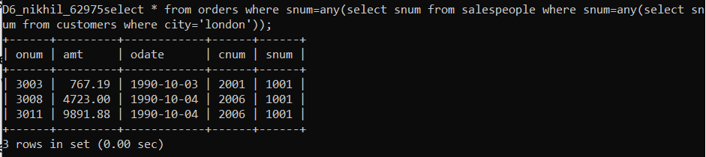

1. Find names and numbers of all salesperson who have more than one customer.

**select sname,snum from salespeople where snum in(select snum from customers group by snum having count(*)>1);**

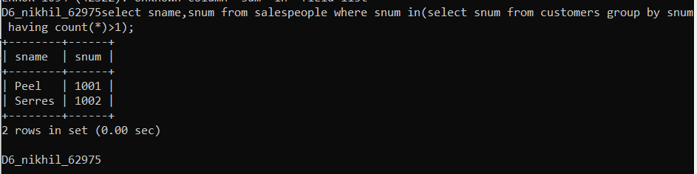

1. Find salespeople number,name and city who have multiple customers.

**select sname,snum,city from salespeople where snum in(select snum from customers group by snum having count(*)>1);**

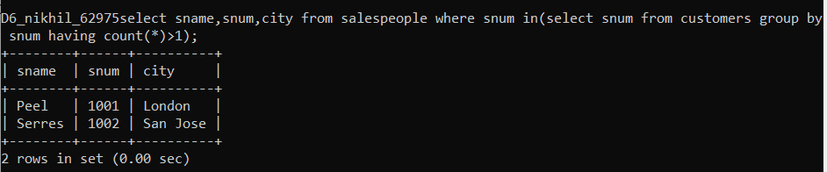

1. Select customers who have a greater rating than any other customer in Rome.

**select * from customers where rating>all(select rating from customers where city='rome') and city!='Rome';**

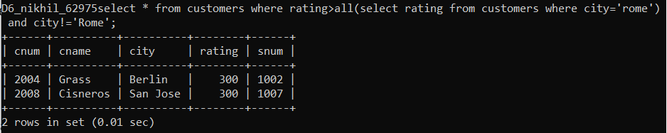

1. Select all orders that had amounts that were greater that atleast one of the orders from ‘1990-10-04’ .

**select * from orders where amt>any(select amt from orders where odate='1990-10-04') and odate!='1990-10-04';**

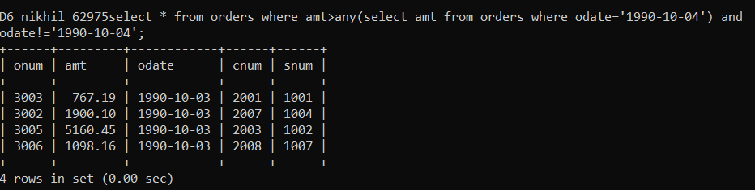

1. Find all orders with amounts smaller than any amount for a customer in San Jose.

**select * from orders where amt<any(select amt from orders where cnum=any(select cnum from customers where city='san jose'));**

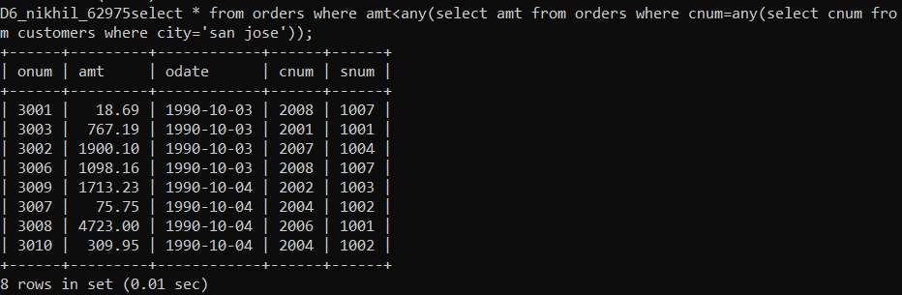

1. Select those customers whose rating are higher than every customer in Paris

**select * from customers where rating>all(select rating from customers where city='paris');**

